Exercise 3 1.
Simulate 100 dogs in the gridworld (0,0)-(1000,1000) with sausage at (800,800) (800,200),(200,800),(200,200) where all dogs start from (500,500) looking for the sausage by:
(1) assuming all dog has a chromosome whose each of 1000 genes are 1, 2, 3 or 4,
(2) moving step by step according to his/her chromosome,
(3) with 1, 2, 3, 4 meaning a movement toward up, down, right, left, respectively.

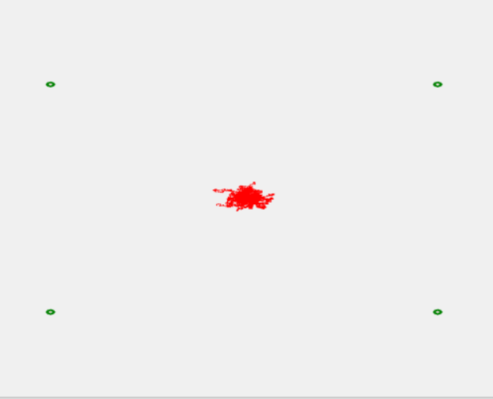
First generation:

50th generation:
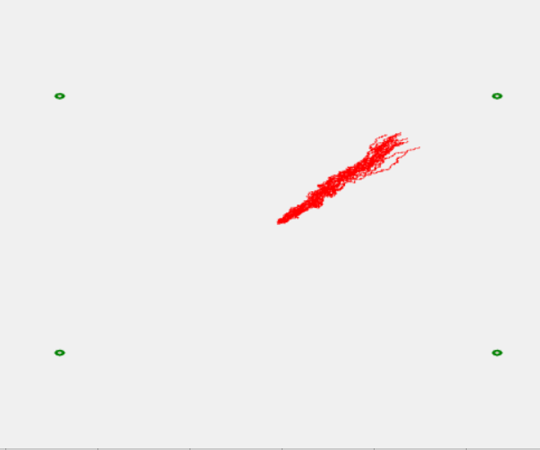

125th generation:
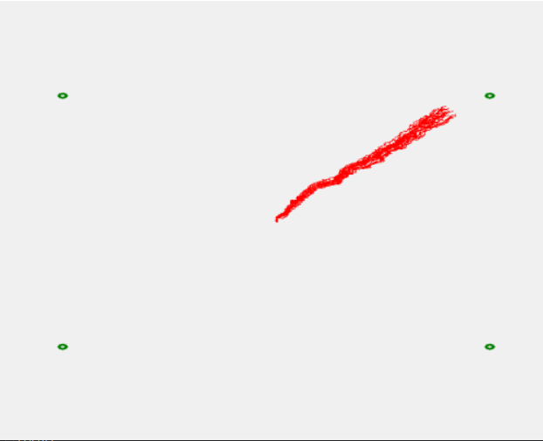

200th generation:
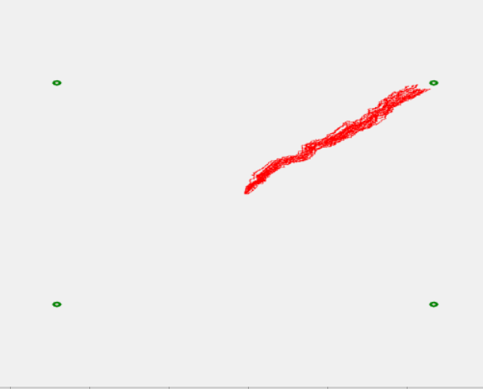

250th generation:
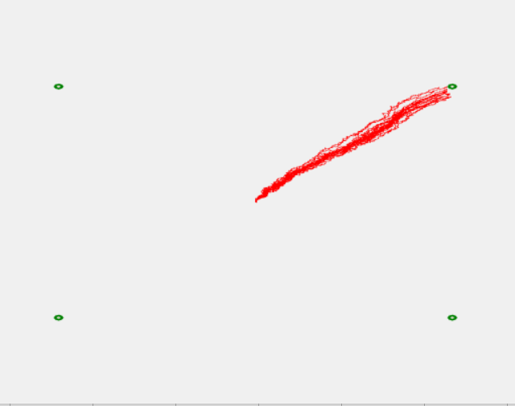

Fitness vs generations:
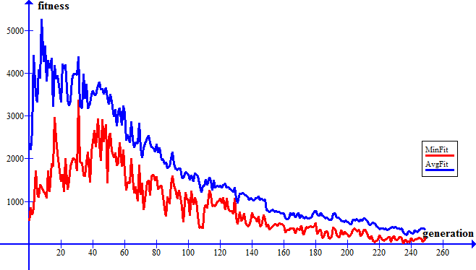

Source code
using System;
using System.Collections.Generic;
using System.ComponentModel;
using System.Data;
using System.Drawing;
using System.Linq;
using System.Text;
using System.Threading.Tasks;
using System.Windows.Forms;
using System.IO;

namespace Siit_3
{
public partial class Form1 : Form
{
Bitmap bit = new Bitmap(1000, 1000);
public Form1()
{
InitializeComponent();

pictureBox1.SizeMode = PictureBoxSizeMode.StretchImage;

}

private void button1_Click(object sender, EventArgs e)
{
StreamWriter avgFitFile = new StreamWriter("averageFit.txt");
StreamWriter maxFitFile = new StreamWriter("maxFit.txt");
StreamWriter numGenFile = new StreamWriter("numGen.txt");
StreamWriter tableFile = new StreamWriter("Table.txt");
StreamWriter tablenum = new StreamWriter("Num.txt");
generation old_gens = new generation();
old_gens.randomize();
old_gens.setFitness();
old_gens.setProbability();
double maxFit = 0;
int numGeneration = 0;
for (int j = 0; (j < 1000) && (numGeneration<250); numGeneration++)
{
bit = new Bitmap(1000, 1000);
for (int i = 0; i < generation.numChromo; i++)
{
PaintWay(old_gens.GetChromo(i));
}
this.Refresh();
if(numGeneration==0 || numGeneration==50 || numGeneration==125 || numGeneration==200 || numGeneration ==249)
MessageBox.Show("gav gav!");
numGenFile.WriteLine(numGeneration.ToString());
Console.WriteLine(old_gens.bestFitness() + " " + old_gens.getAverageFit() + " " + old_gens.getBestArround());
//if (old_gens.bestFitness() == 0) break;
List<int[]> new_tmp = new List<int[]>();
old_gens.Sort(); //for truncate
for (int i = 0; i < generation.numChromo; i++)
{
new_tmp.Add(old_gens.newChild());
}
old_gens.WriteTable(tableFile, tablenum);
generation new_gens = new generation(new_tmp);
old_gens = new_gens;
old_gens.setFitness();
old_gens.setProbability();
avgFitFile.WriteLine(old_gens.getAverageFit().ToString());
maxFitFile.WriteLine(old_gens.bestFitness().ToString());
if (old_gens.bestFitness() > maxFit)
{
maxFit = old_gens.bestFitness();
j = 0;
}
else j++;

}
for (int i = 0; i < generation.numChromo; i++)
{
PaintWay(old_gens.GetChromo(i));
}
tablenum.Close();
tableFile.Close();
numGenFile.Close();
avgFitFile.Close();
maxFitFile.Close();
}
private void PaintWay(int[] chromo)
{
double location_x = 500, location_y = 500;

bit.SetPixel(200, 200, Color.Red);
bit.SetPixel(200, 800, Color.Red);
bit.SetPixel(800, 200, Color.Red);
bit.SetPixel(800, 800, Color.Red);
Graphics graph = Graphics.FromImage(bit);
Pen my_pen = new Pen(Color.Green);
my_pen.Width = 10;
graph.DrawEllipse(my_pen, 800 - 2, 800 - 2, 4, 4);
graph.DrawEllipse(my_pen, 800 - 2, 200 - 2, 4, 4);
graph.DrawEllipse(my_pen, 200 - 2, 800 - 2, 4, 4);
graph.DrawEllipse(my_pen, 200 - 2, 200 - 2, 4, 4);
foreach (int i in chromo)
{
if (i == 1)
{
location_y += 1;
if (location_y == 1000) location_y = 1;
bit.SetPixel((int)location_x,(int) location_y, Color.Red);
}
else if (i == 2)
{
location_x += 1;
if (location_x == 1000) location_x = 1;
bit.SetPixel((int)location_x, (int)location_y, Color.Red);
}
else if (i == 3)
{
location_y -= 1;
if (location_y == 0) location_y = 999;
bit.SetPixel((int)location_x, (int)location_y, Color.Red);
}

else
{
location_x -= 1;
if (location_x == 0) location_x = 999;
bit.SetPixel((int)location_x, (int)location_y, Color.Red);
}

}
pictureBox1.Image = bit;
}
}
}

using System;
using System.Collections.Generic;
using System.Linq;
using System.Text;
using System.Threading.Tasks;
using System.IO;

namespace Siit_3
{
class generation
{
static public int numChromo = 20;
static public int numGens = 1000;
List<int[]> gens;
List<int> fitness { get; }
List<double> sharedFitness;
List<float> probability { get; }
List<int> chromSelect;
List<int[]> location;
List<int> arround;
public int sousage_x1 = 800, sousage_x2 = 800, sousage_x3 = 200, sousage_x4 = 200;
public int sousage_y1 = 800, sousage_y2 = 200, sousage_y3 = 800, sousage_y4 = 200;
public double averagefitness = 0f;
StreamWriter fitOut = new StreamWriter("fitOut.txt");
StreamWriter sharefitOut = new StreamWriter("sharefitOut.txt");
StreamWriter arrOut = new StreamWriter("arrOut.txt");

Random mutat = new Random();
int rando = 0;

public generation()
{
gens = new List<int[]>();
fitness = new List<int>();
probability = new List<float>();
chromSelect = new List<int>();
location = new List<int[]>();
sharedFitness = new List<double>();
arround = new List<int>();

for (int j = 0; j < numChromo; j++)
{
int[] gen = new int[numGens];
location.Add(new int[] { 500,500});
gens.Add(gen);
fitness.Add(0);
arround.Add(0);
sharedFitness.Add(0);
probability.Add(0f);
chromSelect.Add(0);
}
}

public generation(List<int[]> new_gens)
{
gens = new List<int[]>();
fitness = new List<int>();
probability = new List<float>();
chromSelect = new List<int>();
location = new List<int[]>();
sharedFitness = new List<double>();
arround = new List<int>();
gens = new_gens;
for (int j = 0; j < numChromo; j++)
{
location.Add(new int[] { 500, 500 });
fitness.Add(0);
sharedFitness.Add(0);
arround.Add(0);
probability.Add(0f);
chromSelect.Add(0);
}
}

public void randomize()
{
Random rand = new Random();
for (int i = 0; i < numChromo; i++)
{
for (int j = 0; j < numGens; j++)
{

gens[i][j] = rand.Next() % 4 + 1;
}
}
}
public void setFitness()
{
for (int i = 0; i < numChromo; i++)
{
for (int j = 0; j < numGens; j++) //1 - up || y++
{ //2 - right || x++
if (gens[i][j] == 1)
{

location[i][1]++;
if (location[i][1] == 1000)
location[i][1] = 0;
} //3 - down || y--
else if (gens[i][j] == 2)
{

location[i][0]++;
if (location[i][0] == 1000)
location[i][0] = 0;
} //4 - left || x--
else if (gens[i][j] == 3)
{
location[i][1]--;
if (location[i][1] == 0)
location[i][1] = 1000;
}
else {
location[i][0]--;
if (location[i][0] == 0)
location[i][0] = 1000;
}
}
List<int> fit = new List<int>();
fit.Add( Math.Abs(sousage_x1 - location[i][0]) + Math.Abs(sousage_y1 - location[i][1]));
fit.Add(Math.Abs(sousage_x2 - location[i][0]) + Math.Abs(sousage_y2 - location[i][1]));
fit.Add(Math.Abs(sousage_x3 - location[i][0]) + Math.Abs(sousage_y3 - location[i][1]));
fit.Add(Math.Abs(sousage_x4 - location[i][0]) + Math.Abs(sousage_y4 - location[i][1]));
fitness[i] = fit.Min();
fitOut.WriteLine(fitness[i]);
}
for(int i = 0; i < numChromo; i++)
{
double sum = 0;
for(int j = 0; j < numChromo; j++)
{
int tmp = Math.Abs(location[i][0] - location[j][0]) + Math.Abs(location[i][1] - location[j][1]);
if (tmp < 50)
{
arround[i]++;
sum += (1 - (double)tmp / 50);
}
}
sharedFitness[i] = (fitness[i])*sum;
sharefitOut.WriteLine(sharedFitness[i]);
arrOut.WriteLine(arround[i]);
}
fitOut.Close();
sharefitOut.Close();
arrOut.Close();
}

public void setProbability()
{
double mass = 0;
for (int i = 0; i < numChromo; i++)
{
mass += sharedFitness[i];
}
averagefitness = mass / numChromo;
for (int i = 0; i < numChromo; i++)
{
probability[i] = (float)fitness[i] / (float)mass;
}
}
public int[] newChild()
{

Random rand = new Random(DateTime.Now.TimeOfDay.Milliseconds + rando);
rando++;
if (rando == 10000000) rando = 0;
int rand_num = rand.Next(numChromo/2);
float sum = 0f;
int[] chrom_1 = new int[numGens], chrom_2 = new int[numGens];

//for (int i = 0; i < 100; i++)
//{
// sum += probability[i] * numGens000000;
// if (rand_num <= sum)
// {
// chromSelect[i]++;
// chrom_1 = gens[i];
// break;
// }

//}
chrom_1 = gens[rand_num]; // for truncate
sum = 0f;
rand_num = rand.Next(numChromo/2);
//for (int i = 0; i < 100; i++)
//{
// sum += probability[i] * numGens000000;
// if (rand_num <= sum)
// {
// chromSelect[i]++;
// chrom_2 = gens[i];
// break;
// }
//}
chrom_2 = gens[rand_num]; // for truncate

int[] new_chrom = new int[numGens];

//uniform crossover
for (int i = 0; i < numGens; i++)
{
if (rand.Next() % 2 == 1) new_chrom[i] = chrom_1[i];
else new_chrom[i] = chrom_2[i];
}

//one point crossover
//int point = rand.Next() % numGens;
//for (int i = 0; i < numGens; i++)
//{
// if (i < point) new_chrom[i] = chrom_1[i];
// else new_chrom[i] = chrom_2[i];
//}
Mutation(new_chrom);
return new_chrom;
}
public double bestFitness()
{
return sharedFitness.Min();
}

public void Sort()
{
for (int i = 0; i < numChromo - 1; i++)
{
bool swapped = false;
for (int j = 0; j < numChromo - i - 1; j++)
{
if (sharedFitness[j] > sharedFitness[j + 1])
{
int[] tmp_gen = gens[j];
gens[j] = gens[j + 1];
gens[j + 1] = tmp_gen;

int tmp_fit = fitness[j];
fitness[j] = fitness[j + 1];
fitness[j + 1] = tmp_fit;

double tmp_shr_fit = sharedFitness[j];
sharedFitness[j] = sharedFitness[j + 1];
sharedFitness[j + 1] = tmp_fit;
swapped = true;
}

}
if (!swapped) break;
}
}
public double getAverageFit()
{
return averagefitness;
}
public void WriteTable(StreamWriter file1, StreamWriter file2)
{
for (int i = 0; i < numChromo; i++)
{
file1.WriteLine(chromSelect[i].ToString());
file2.WriteLine(i.ToString());
}
file1.WriteLine();
file1.WriteLine();
}
public int[] GetMaxChromo()
{
return gens[0];
}
public int[] GetChromo(int index)
{
return gens[index];
}

private void Mutation(int[] chromo)
{
for(int i = 0;i<numGens;i++)
{
if(mutat.Next()%50 == 1)
{
int tmp = mutat.Next() % 4 + 1;
if (tmp == chromo[i]) chromo[i] = (tmp + 1) % 4 + 1;
}
}
}
public int getBestArround()
{
return arround.Min();
}

}
}

